Flash Group Quality Engineering Project
Date: Tuesday 9 March 2026
Group: Khumbelo Thanduvatho & Amarah Morgan

Task 1: Infrastructure and Git Governance
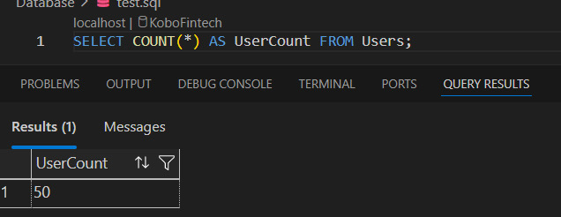
  - Database Initialisation:

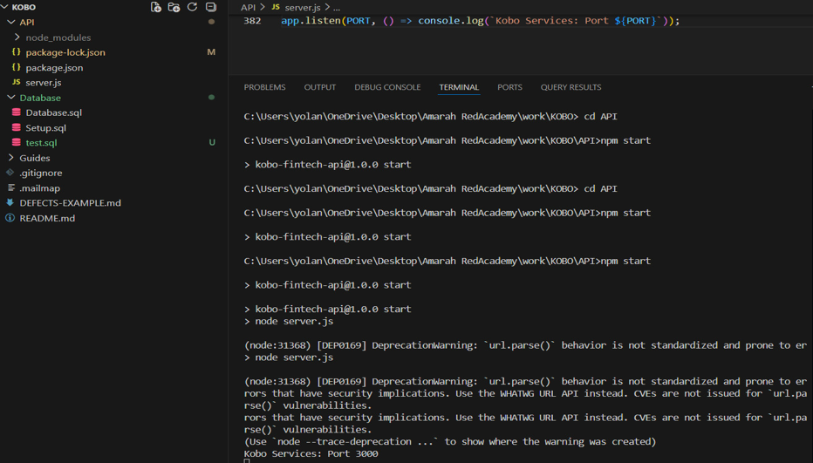
1.2 API Deployment:

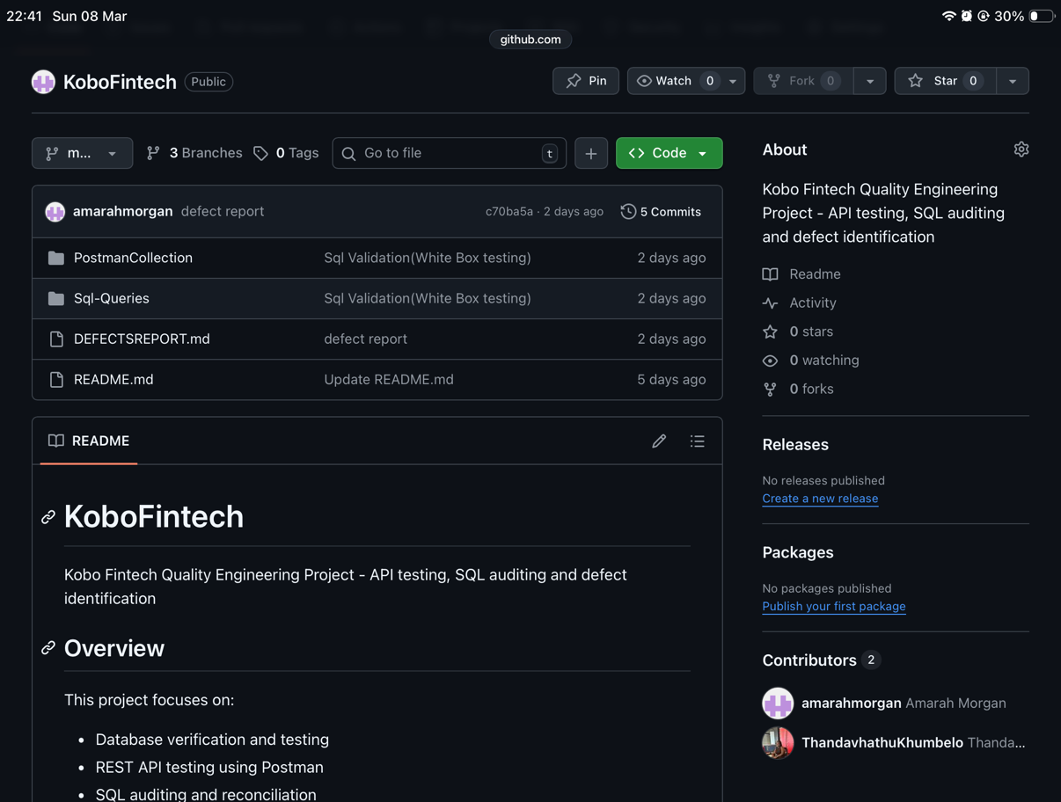
  - Git Strategy:

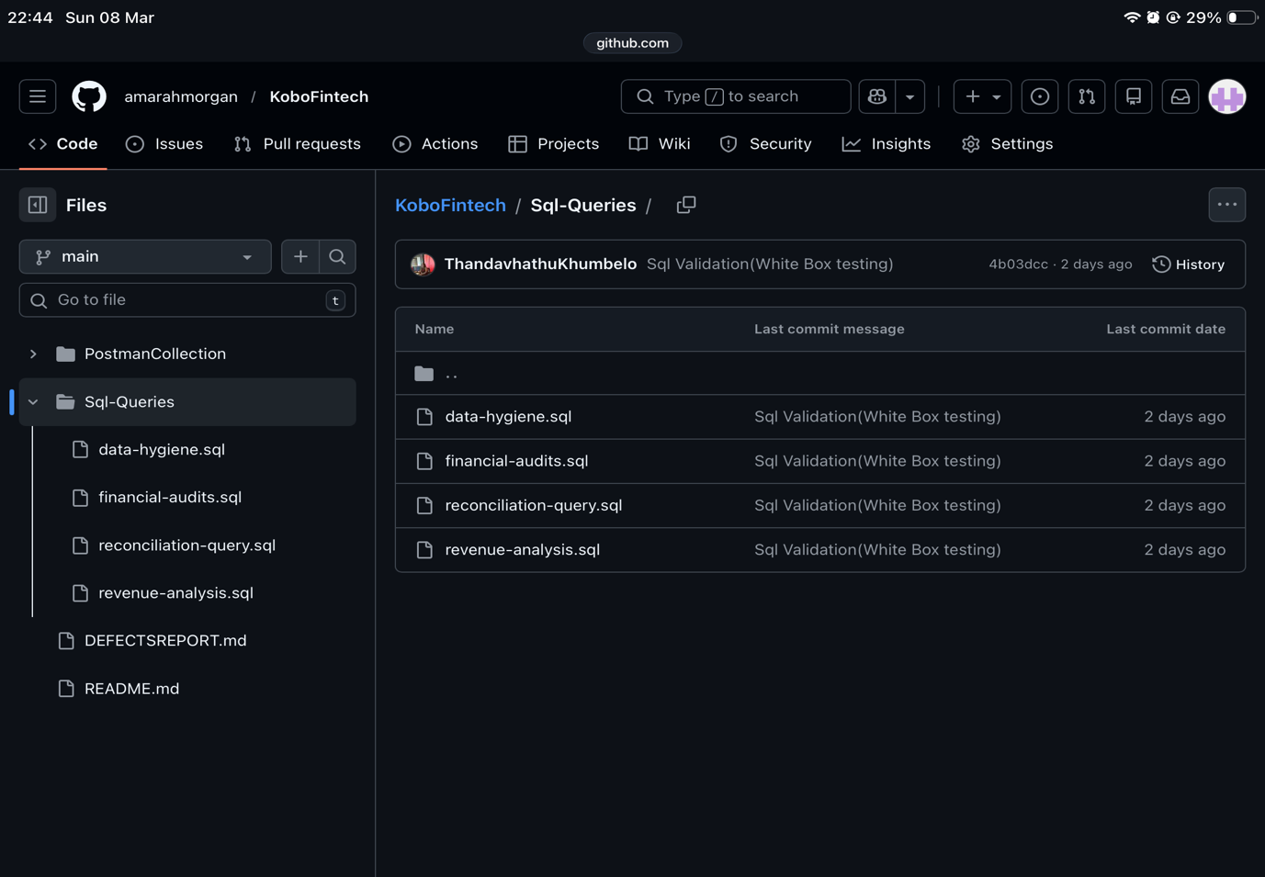
  - Traceability: Every SQL script or Postman update must be linked to a specific commit.

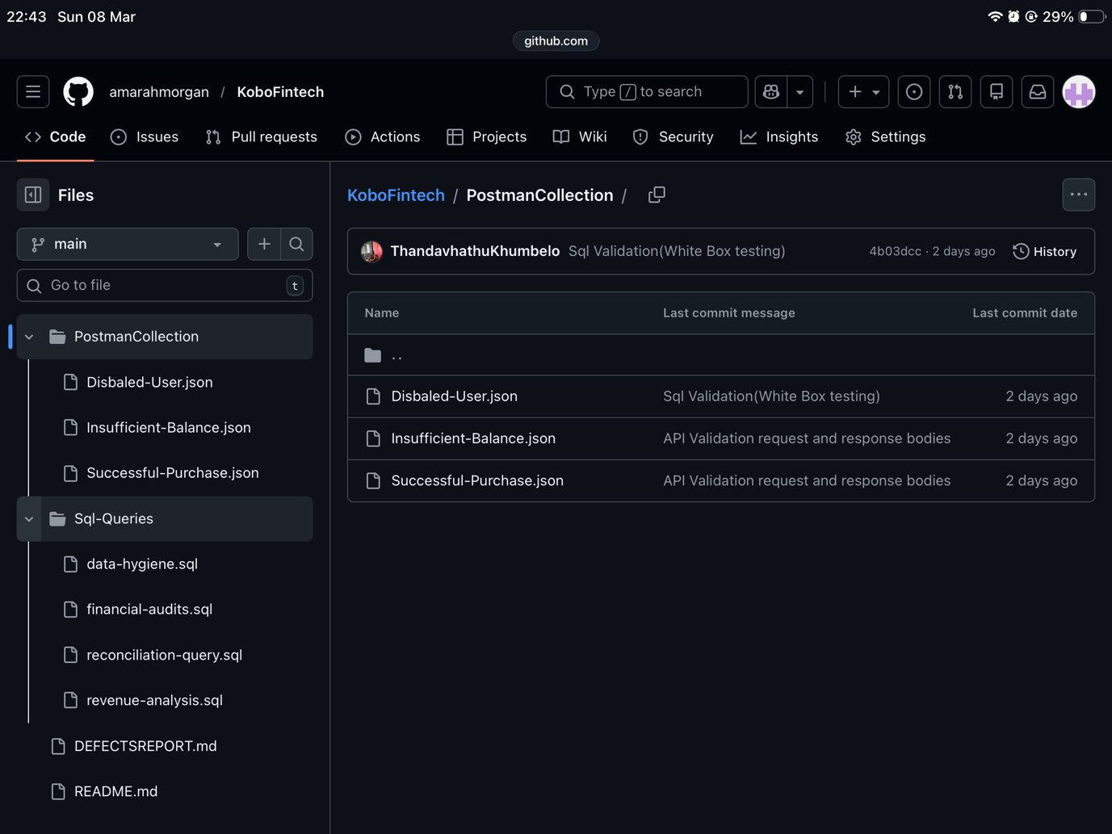
Task 1 Question:
When testing the API in a staging environment instead of a local environment, the dbConfig in server.js should not contain hard-coded database credentials. Instead, sensitive information such as the database username, password, and server address should be stored in environment variables using a .env file or a secure configuration system. The server.js file would then reference these values using process.env, for example process.env.DB_USER and process.env.DB_PASSWORD. This ensures that the actual credentials are not committed to the GitHub repository or its history, reducing the risk of credential leaks. The .env file should also be added to the .gitignore file so that it is excluded from version control, allowing different configurations to be used safely for local development and staging environments.

Task 2: API Functional Validation
2.1 Standard Validation:
Test Case:
Execute a successful purchase. Verify the 201 Created status and the presence of a traceId.
Expected Results:
- The API should process the purchase successfully.
- The response should return HTTP Status Code: 201 Created.
- The response body should have a traceId value used for request tracking.
- The response should be valid JSON including the walletId, productId and reference.

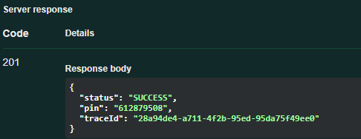
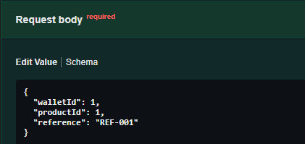
Swagger:

Actual Results:
- The purchase request executed successfully.
- The API returned HTTP Status Code: 201 Created.
- The response body included a traceId value.
- The response format was valid JSON.
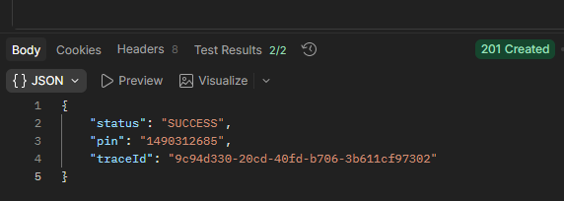
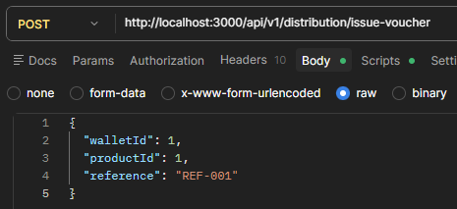
Postman:

Conclusion:
The Actual Result matches the Expected Result, showing that the purchase of the distribution issue-voucher endpoint works correctly and the test passed.

2.2 Business Logic Testing:
User:
{
"data": {
"WalletID": 10,
"UserID": 10,
"Balance": -5,
"CurrencyCode": "ZAR",
"LastUpdated": "2026-03-03T12:50:06.447Z",
"FullName": "User_10",
"MSISDN": "27711000010",
"ServiceStatus": "Active"
},
"traceId": "36706e66-46ec-458b-8e00-f887b8831746"
}

Test Case:
Attempt to purchase a product where the product cost is higher than the wallet balance.
Expected Results:
- System rejects the purchase
- API returns an error status code (400 or 402)
- Error message indicates insufficient wallet balance
- Wallet balance remains unchanged
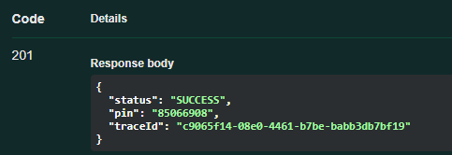
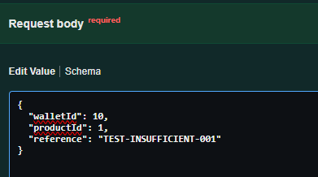
Swagger:

Actual Results:
- API returned 201 Created
- Transaction was successfully processed even though the wallet balance was insufficient
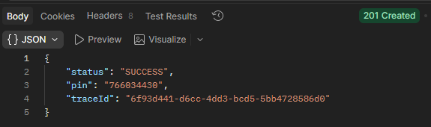
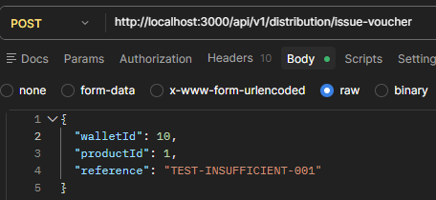
Postman:

Defect Report:
- The system allows a purchase transaction even when the wallet balance is lower than the product cost, which violates business logic rules and could result in negative balances or financial loss.

- Severity: Critical
- Type: Business Logic Defect

2.3 MSISDN Integrity:
Disabled User:
{
"data": {
"UserID": 5,
"MSISDN": "27711000005",
"FullName": "User_5",
"AccountTier": "Standard",
"ServiceStatus": "Disabled",
"CreatedAt": "2026-03-03T12:50:06.447Z",
"WalletID": 5,
"Balance": 577.5,
"CurrencyCode": "ZAR"
},
"traceId": "2f75c2c6-8c2e-4815-81e4-4d945dbdfe7d"

Test Case:
Identify a user in the database with a Disabled status. Attempt a transaction for that user and evaluate the outcome.
Expected Results:
- The system should not allow voucher issuance for a user whose account status is Disabled.
- The system should return an error response such as 403 Forbidden or 400 Bad Request.
- The voucher should not be issued, and the transaction should be rejected.
- No purchase should be created in the system.


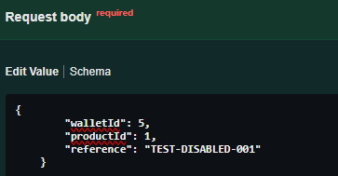
Swagger:

Actual Results:
- The API successfully processed the request.
- The response returned HTTP Status Code: 201 Created.
- A voucher was issued even though the user account status is Disabled.
- The response included a traceId confirming the transaction was processed.
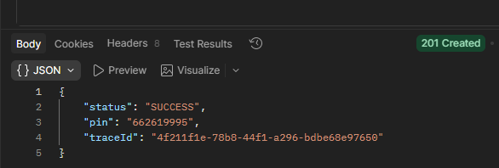
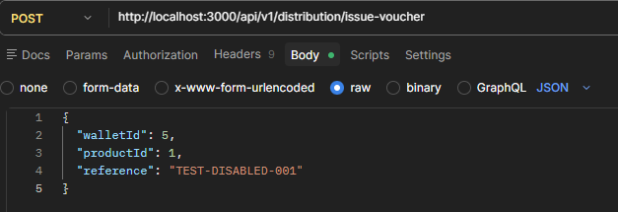
Postman:

Conclusion:
The defect found is that the system allows transactions for users whose accounts are Disabled, which violates expected business rules. The API should prevent transactions for inactive or disabled accounts.
Severity: High
Reason: Disabled users should not be able to perform financial transactions / Unauthorised transactions could occur using inactive accounts.

2.4 Automation:
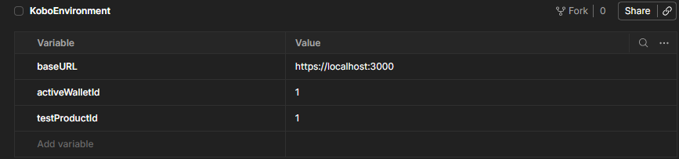
Task 2 Question:
No, the API did return the same error message. Providing specific error messages can create security risks because attackers can use these messages to discover valid wallet IDs or identify disabled accounts. This process is known as user or resource enumeration. For better security, APIs should provide more generic error messages such as "Invalid request" to avoid revealing internal system details. an attacker can test many wallet IDs to discover which ones exist in the system. This can lead to potential fraud attempts. For security reasons, APIs should return more generic error messages such as “Invalid request” to avoid exposing sensitive system details.

Task 3: Database Audit (White-Box)
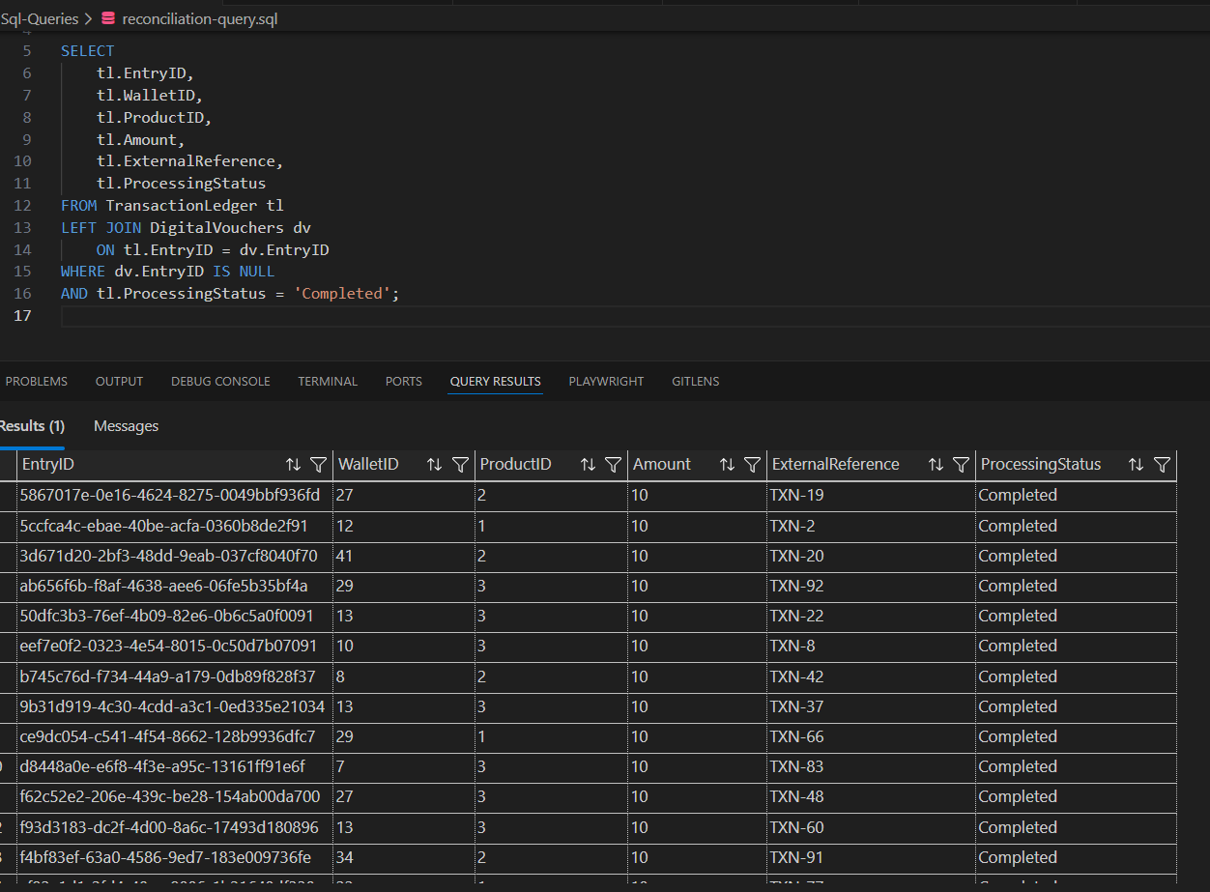
3.1 Reconciliation Query:

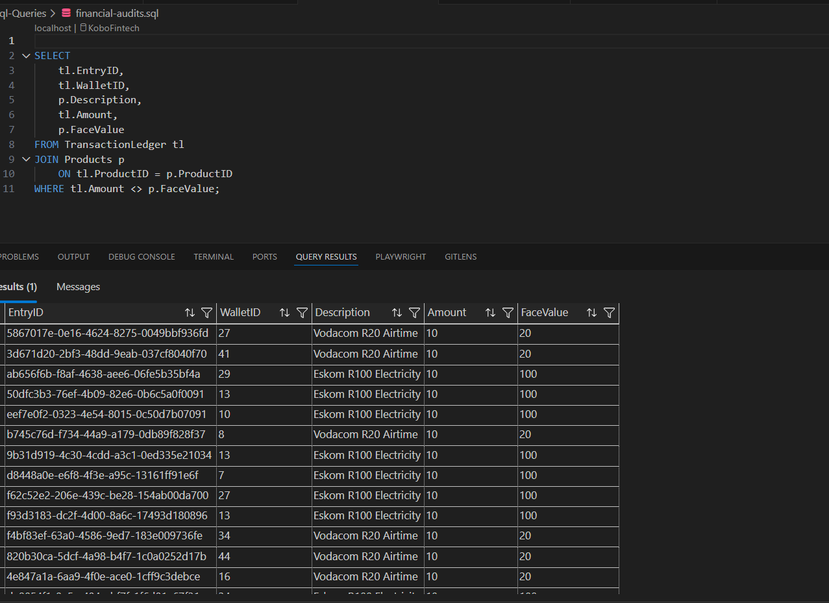
3.2 Financial Audit:

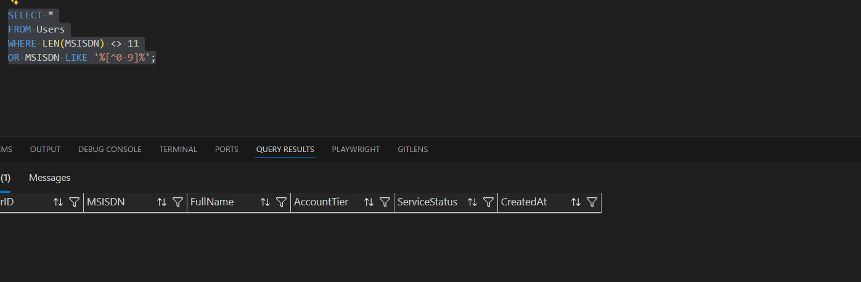
3.3 Data Hygiene:

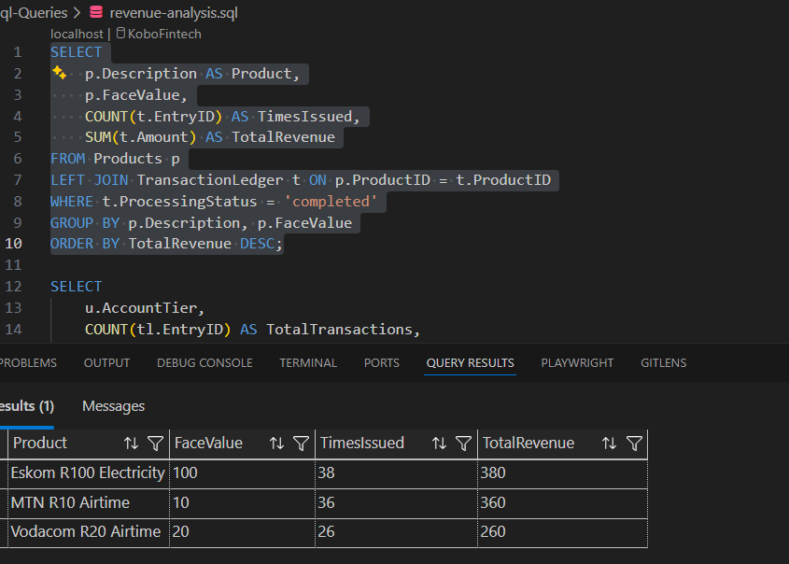
3.4 Revenue Analysis:

Question 3:
The problematic data type is the float data type. In the provided tables the balance,
amounts and face value are floats. Float is bad for money because it stores numbers as
approximate values not as the exacts values. Financial systems (banking, wallets,
payments) require exact precision, since even very small rounding errors can lead to
incorrect balances. Float uses binary floating-point representation, which means many decimal numbers cannot be stored exactly. The database stores the closest approximation, which can create rounding errors during calculations.

Example from the database:
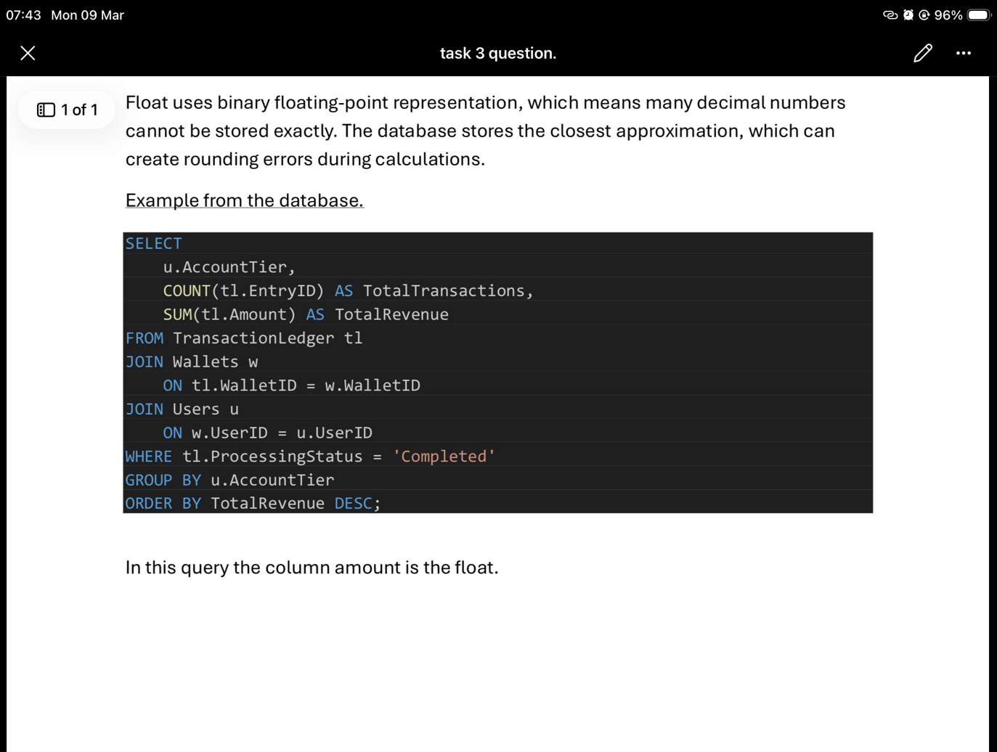
In this query the column amount is the float.

Task 4: Defect Identification and Risk Assessment
4.1 Procedural Flaws:
The usp_IssueDigitalVoucher stored procedure contains several procedural flaws that make it unsafe for a high-traffic production environment. Firstly, the procedure generates voucher PINs using CAST(ABS(CHECKSUM(NEWID())) AS NVARCHAR). This method is not secure or guaranteed to produce unique values. In a high-traffic system where many vouchers may be generated simultaneously, this approach could result in duplicate voucher PINs. Voucher codes should instead be generated using a secure random method and enforced with a unique constraint or primary key to ensure that duplicates cannot occur.
Secondly, the procedure performs voucher issuance without transactional protection. There is no BEGIN TRANSACTION, COMMIT, ROLLBACK, or TRY...CATCH error handling implemented. This means that if an error occurs during the execution of the procedure, some operations may complete while others fail. For example, a voucher could be inserted into the DigitalVouchers table without the corresponding product or order state being properly recorded. Voucher issuance should be atomic, meaning all steps must succeed together or all changes should be rolled back.
Thirdly, the procedure lacks concurrency control mechanisms to prevent duplicate issuance when multiple requests are processed at the same time. In high-traffic environments where many users may request vouchers simultaneously, this could lead to race conditions where duplicate vouchers are created or inconsistent records are generated. Without appropriate locking or validation mechanisms, the system may produce unreliable results under heavy load

4.2 Structural Flaws:
The Kobo Fintech database also contains several structural flaws that violate quality engineering standards. One major issue is that financial values are stored using the FLOAT data type. For example, the Wallets table stores the Balance as FLOAT, the Products table stores the FaceValue as FLOAT, and the TransactionLedger table stores the Amount as FLOAT. The FLOAT data type is an approximate data type that can introduce rounding and precision errors during calculations. Financial systems require precise and deterministic data types, such as DECIMAL, to ensure accurate monetary calculations.
Another structural flaw is the absence of balance validation before deducting funds from a wallet. The stored procedure subtracts the product value from the wallet balance without first checking whether the wallet has sufficient funds. This could allow transactions to proceed even when the wallet balance is insufficient, potentially resulting in negative balances. Such behaviour violates basic financial and business rules and can lead to inaccurate financial records.
A further issue is the lack of transaction control across multiple database operations. The procedure updates the wallet balance, inserts a transaction ledger entry, and generates a voucher without wrapping these operations within a database transaction. If one of these steps fails, the database may end up in an inconsistent state where some records are updated while others are not.

4.3 Impact Mapping:
One of the most critical issues is the use of the FLOAT data type for financial calculations. The financial impact of this flaw is that rounding and precision errors may occur during monetary calculations. These inaccuracies could lead to incorrect wallet balances, incorrect transaction values, and reconciliation problems between systems. Over time, these small errors may accumulate and result in significant financial discrepancies.

The legal impact of this issue is also serious. Incorrect balances or transaction values may lead to disputes between the company and its customers. If customers believe they were charged incorrectly, this could result in complaints, regulatory scrutiny, or potential penalties. In financial systems, maintaining precise and reliable financial records is a legal and regulatory requirement.

Another critical issue is the lack of transaction control in the usp_IssueDigitalVoucher procedure. From a financial perspective, the absence of transactions could result in partial operations being completed. For example, the wallet balance may be deducted successfully while the voucher generation fails. In such cases, the customer loses money but does not receive the voucher they paid for, leading to revenue loss and refund requests.

From a legal perspective, charging customers without delivering the promised service could expose Kobo Fintech to fraud accusations, regulatory investigations, and potential violations of consumer protection laws. Customers could also pursue legal claims for financial damages if they suffer losses due to system failures.

Question 4:
If the system crashes during the execution of the transaction process, the Wallets table is the most likely to contain dirty or inconsistent data. This is because the wallet balance is updated before all other operations are completed. If the system crashes after the balance has been deducted but before the voucher or transaction ledger entry is created, the wallet will show a reduced balance even though the transaction was not completed successfully.
This issue can be resolved by implementing proper database transactions to ensure ACID consistency. All related operations should be wrapped within a single transaction block so that they either succeed together or fail together. If an error occurs during the process, the transaction should be rolled back to ensure that no partial updates remain in the database. This approach prevents dirty data and ensures the integrity of the financial records.

